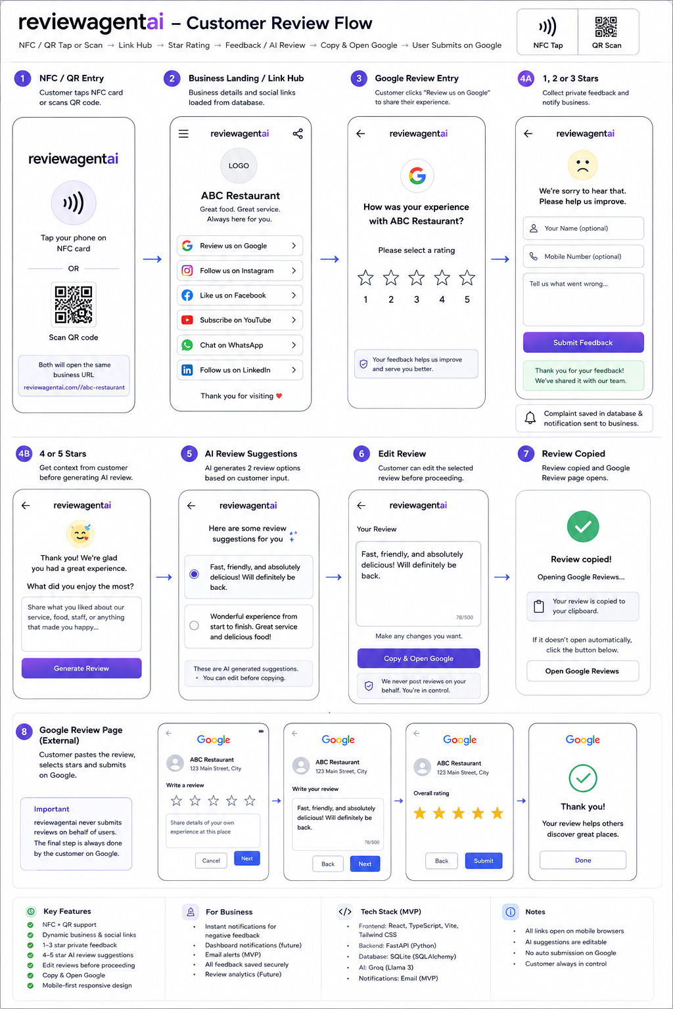

reviewagentai — Production-Ready MVP Implementation Prompt
You are an expert Lead Software Architect, Senior Full-Stack Developer, UI/UX Engineer, and AI Engineer.
Your task is to design and build a production-ready MVP for an application called reviewagentai.
Do not generate the entire application in one step. First create a clear, phased implementation plan, then implement the application phase by phase while maintaining a clean, scalable architecture.

1. Product Overview
reviewagentai is a mobile-first customer feedback and review-assistance platform.
The system is accessed through a business-specific NFC card or QR code. A customer can:
- View the business profile.
- Access the business’s Google Review page.
- Follow or connect with the business on social platforms.
- Provide private feedback when their experience is poor.
- Receive AI-assisted review suggestions when they have a positive experience.
- Edit the AI-generated review before submitting it.
- Copy the final review and open the business’s official Google review page.
The system must never automatically submit a review to Google.
The customer must always have control over the final review content and must manually submit it on Google.

2. Important Product Principles
Follow these principles throughout the implementation:
- Mobile-first
  - The primary user is accessing the application from a mobile phone.
  - NFC and QR flows must work correctly on mobile browsers.
  - UI must be responsive on mobile, tablet, and desktop.
- Customer-controlled reviews
  - Never automatically post or submit reviews.
  - AI-generated content is only a suggestion.
  - Customers must be able to edit AI-generated content.
  - The customer explicitly decides whether to copy/open Google.
- No automatic review generation without customer input
  - Do not generate a review immediately when the page loads.
  - First collect the customer’s rating and/or feedback/context.
  - AI generation should only happen after the customer provides appropriate input.
- Business-specific configuration
  - Business information must be dynamically loaded using a unique business identifier/slug.
  - Google and social-media links must come from the database.
- Clean separation of concerns
  - UI, API, business logic, database, AI services, and notification services must be logically separated.
  - Avoid putting business logic directly inside React components.
- Production-ready foundation
  - Environment-based configuration.
  - Input validation.
  - Error handling.
  - Logging.
  - Security controls.
  - Database constraints.
  - API validation.
  - Testable services.

3. Core Architecture & Technology Stack

Frontend
Use:
- React.js
- TypeScript
- Vite
- Tailwind CSS
- React Router
- Modern component-based architecture
The frontend should be a responsive SPA.

Backend
Use:
- Python
- FastAPI
- Pydantic
- SQLAlchemy
- REST APIs
The backend must expose clean REST endpoints for:
- Business information
- Social links
- Customer feedback
- AI review generation
- Review events
- Notifications
- Health checks

Database
Use:
- SQLite for the MVP
- SQLAlchemy ORM
- Alembic for database migrations
Design the schema so that migrating from SQLite to PostgreSQL later is straightforward.
Do not tightly couple business logic to SQLite-specific behavior.

AI
Use:
- Groq Python SDK
- groq.Groq()
- Environment variable for API key
- Configurable model name
The AI service should generate natural, short, human-sounding review suggestions based on:
- Business name
- Business category
- Business description
- Customer-selected rating
- Customer-provided positive experience/comments
- Optional business-specific keywords
Do not hard-code the generated review.

4. Complete Customer Business Flow

STEP 1 — NFC / QR Entry
Each business receives a unique URL such as:
https://reviewagentai.com/r/{business_slug}
or an equivalent clean route.
The same URL must be encoded into:
- NFC card
- QR code
The customer can therefore:

Option A — NFC
Customer taps their mobile phone against the NFC card.

Option B — QR
Customer scans the QR code using their mobile phone.
Both methods must open the same mobile-optimized business landing page.

5. STEP 2 — Business Landing / Link Hub
After opening the business URL:
/r/{business_slug}
the application retrieves the business configuration from the database.
Display:
- Business logo
- Business name
- Business description/tagline
- Google Review button
- Instagram button
- Facebook button
- YouTube button
- WhatsApp button
- LinkedIn button
Example:
--------------------------------
[Business Logo]
ABC Restaurant
Great food. Great service.
--------------------------------
⭐ Review us on Google
📸 Follow us on Instagram
👍 Like us on Facebook
▶️ Subscribe on YouTube
💬 Chat with us on WhatsApp
💼 Follow us on LinkedIn
--------------------------------
Thank you for visiting ❤️
--------------------------------
All links must be dynamically loaded from the database.
Social links such as:
- Instagram
- Facebook
- YouTube
- WhatsApp
- LinkedIn
should directly open their configured destination.
The links must work correctly in mobile browsers.

6. STEP 3 — Google Review Selection
When the customer clicks:
“Review us on Google”
do NOT immediately redirect to Google.
Instead, open the reviewagentai review experience.
Display:
--------------------------------
Google Review
How was your experience
with us?
☆ ☆ ☆ ☆ ☆
1 2 3 4 5
--------------------------------
The customer selects between 1 and 5 stars.

7. STEP 4A — 1–3 Star Experience
If the customer selects:
- 1 star
- 2 stars
- 3 stars
the application should keep the customer inside reviewagentai.
Do NOT redirect them to Google.
Show a private feedback form.
Example:
--------------------------------
We're sorry to hear that.
Please tell us what
we can improve.
[ Your Name ]
[ Mobile Number (Optional) ]
[ Tell us what went wrong... ]
[ Submit Feedback ]
--------------------------------
The feedback should be stored in:
local_complaints
The database record should include appropriate information such as:
- business_id
- rating
- customer_name
- phone_number
- comments
- created_at
- status
- notification_status
The backend should validate all incoming data.
The application should provide a clear confirmation after successful submission:
Thank you for your feedback.
Your feedback has been shared
with the business team.

8. Negative Feedback Notification
When a 1–3 star complaint is submitted:
- Save the complaint.
- Trigger the notification service.
- Notify the business owner/admin.
The notification architecture should support:
- Dashboard notification
- Email notification
The notification layer should be abstracted so that SMS or other providers can be added later.
Do not tightly couple the complaint service to a specific notification provider.
Example architecture:
Complaint Submitted
↓
Complaint Service
↓
Notification Service
↓
┌───────────────┐
│ Dashboard │
│ Email │
│ Future: SMS │
└───────────────┘

9. STEP 4B — 4–5 Star Experience
If the customer selects:
- 4 stars
- 5 stars
the application should ask for customer input before generating AI content.
Example:
--------------------------------
Thanks for the feedback!
What did you enjoy about
your experience?
[ Great food and friendly staff ]
[ Generate Review ]
--------------------------------
The AI must use the customer’s input as the primary source for generating the review.
Do not fabricate specific facts about the customer’s experience.

10. AI Review Generation
After customer input is provided, call the FastAPI backend.
Example:
POST /api/reviews/generate
The backend calls the Groq service.
The AI should generate 2 distinct review suggestions.
Example:
AI Review Suggestions
○ "Fast, friendly, and absolutely
delicious! Will definitely be back."
○ "Wonderful experience from start
to finish. Great service and
delicious food!"
The suggestions should be:
- Short
- Natural
- Human-sounding
- Business-specific
- Based on customer input
- Non-repetitive
- Grammatically correct
- Appropriate for Google reviews
Do not generate fake claims.
Do not invent:
- Specific employees
- Specific products
- Specific services
- Specific events
- Specific discounts
- Specific experiences
unless they were provided by the customer or configured as verified business information.

11. AI Review Editing
The customer must be able to edit the selected AI suggestion.
Example:
--------------------------------
Your Review
[ Fast, friendly, and absolutely
delicious! Will definitely be
back. ]
✎ Edit
--------------------------------
[ Copy & Open Google ]
--------------------------------
The AI output is only a starting suggestion.
The customer has complete control over the final text.

12. Copy & Open Google
When the customer clicks:
“Copy & Open Google”
perform the following sequence:
- Take the customer’s final edited review.
- Copy the text to the device clipboard.
- Open the configured Google review URL.
- Prefer opening Google in a new browser tab/window when supported.
- Show a small confirmation before navigation if required by browser behavior.
Example:
Review copied!
Opening Google Reviews...
The customer then manually:
- Selects their Google rating.
- Pastes the copied review.
- Reviews/edits it if desired.
- Submits the review themselves.
reviewagentai must never submit the Google review automatically.

13. Database Design
Create SQLAlchemy models for at least:

Business
Fields should include:
- id
- slug
- name
- logo_url
- description
- category
- google_review_url
- created_at
- updated_at
- status

SocialLink
Fields should include:
- id
- business_id
- platform
- url
- display_order
- enabled
- created_at
- updated_at
Supported platforms:
- GOOGLE
- INSTAGRAM
- FACEBOOK
- YOUTUBE
- WHATSAPP
- LINKEDIN

LocalComplaint
Fields should include:
- id
- business_id
- rating
- customer_name
- phone_number
- comments
- status
- notification_status
- created_at
- updated_at

GeneratedPositiveReview
Fields should include:
- id
- business_id
- rating
- customer_input
- generated_review
- selected
- created_at
Do not store unnecessary customer information.

14. API Design
Create versioned REST APIs.
Example:
GET /api/v1/businesses/{slug}
GET /api/v1/businesses/{business_id}/links
POST /api/v1/complaints
POST /api/v1/reviews/generate
POST /api/v1/reviews/events
GET /api/v1/health
Use:
- Pydantic request models
- Pydantic response models
- Proper HTTP status codes
- Centralized exception handling
- Structured logging
- Input validation

15. Frontend Screen Structure
Create reusable React components.
Suggested structure:
src/
├── components/
│ ├── BusinessHeader
│ ├── BusinessLogo
│ ├── SocialLinkCard
│ ├── GoogleReviewCard
│ ├── StarRating
│ ├── FeedbackForm
│ ├── ReviewGenerator
│ ├── ReviewOption
│ ├── ReviewEditor
│ ├── CopyOpenGoogleButton
│ ├── LoadingState
│ ├── ErrorState
│ └── SuccessMessage
│
├── pages/
│ ├── BusinessLandingPage
│ ├── GoogleReviewPage
│ ├── FeedbackPage
│ └── PositiveReviewPage
│
├── services/
│ ├── api.ts
│ ├── businessService.ts
│ ├── complaintService.ts
│ └── reviewService.ts
│
├── hooks/
├── types/
├── utils/
└── App.tsx

16. Backend Structure
Use a clean modular FastAPI architecture:
backend/
├── app/
│ ├── main.py
│ │
│ ├── api/
│ │ └── v1/
│ │ ├── businesses.py
│ │ ├── complaints.py
│ │ ├── reviews.py
│ │ ├── notifications.py
│ │ └── health.py
│ │
│ ├── models/
│ │ ├── business.py
│ │ ├── social_link.py
│ │ ├── complaint.py
│ │ └── generated_review.py
│ │
│ ├── schemas/
│ │
│ ├── services/
│ │ ├── business_service.py
│ │ ├── complaint_service.py
│ │ ├── review_service.py
│ │ ├── groq_service.py
│ │ └── notification_service.py
│ │
│ ├── db/
│ │ ├── database.py
│ │ └── migrations/
│ │
│ ├── core/
│ │ ├── config.py
│ │ └── logging.py
│ │
│ └── utils/
│
├── tests/
└── requirements.txt

17. Security Requirements
Implement basic production security from the beginning.
Include:
- Environment variables for secrets.
- Never hard-code Groq API keys.
- CORS configuration.
- Input validation.
- Request size limits where appropriate.
- Rate limiting for AI-generation endpoints.
- Protection against prompt injection through customer input.
- SQLAlchemy parameterized queries.
- Secure error responses.
- No sensitive information in logs.
- Basic abuse prevention.

18. Configuration
Use environment variables.
Example:
APP_ENV=development
DATABASE_URL=sqlite:///./reviewagentai.db
GROQ_API_KEY=your-key
GROQ_MODEL=your-model
FRONTEND_URL=http://localhost:5173
CORS_ORIGINS=http://localhost:5173
Provide:
.env.example
Never commit .env.

19. Error Handling
The application must gracefully handle:

Frontend
- Business not found
- Invalid business slug
- API unavailable
- AI generation failure
- Clipboard permission failure
- Google URL unavailable
- Network timeout

Backend
- Validation errors
- Database errors
- Groq API errors
- Notification failures
- Unexpected exceptions
The user should always receive a friendly message rather than a technical stack trace.

20. Testing Strategy
Implement tests for:

Backend
- Business lookup
- Social links
- Star rating logic
- 1–3 star complaint creation
- 4–5 star AI generation
- Invalid input
- AI service failure
- Notification triggering

Frontend
- Business landing page
- Social link rendering
- Star selection
- Negative feedback form
- AI review generation
- Review editing
- Clipboard functionality
- Copy & Open Google flow

Critical business-flow tests
Verify:
NFC/QR
↓
Business Landing
↓
Google Review
↓
1–3 Stars
↓
Private Feedback
and:
NFC/QR
↓
Business Landing
↓
Google Review
↓
4–5 Stars
↓
Customer Input
↓
AI Suggestions
↓
Edit
↓
Copy
↓
Open Google
↓
Customer Manually Submits

21. UX Requirements
The UI should feel:
- Modern
- Trustworthy
- Simple
- Fast
- Mobile-first
- Professional
- Accessible
Avoid unnecessary screens.
The customer should be able to reach the desired action within a few taps.
Use:
- Large touch targets
- Clear CTA buttons
- Accessible contrast
- Loading indicators
- Empty states
- Error states
- Success states
- Smooth transitions
- Responsive layouts
Do not overload the customer with unnecessary information.

22. QR Code Support
The application must support QR-based entry in addition to NFC.
The QR code itself should contain the same business-specific URL used by NFC.
Example:
https://reviewagentai.com/r/abc-restaurant
The application does not need a separate QR business flow.
Both:
NFC → Business URL
QR → Business URL
must converge into the same React landing page.

23. Future-Ready Architecture
Although this is an MVP, design the architecture so that the following can be added later without major restructuring:
- Business Owner Dashboard
- Authentication
- Multi-tenancy
- Role-based access control
- PostgreSQL
- Redis
- Email provider
- SMS provider
- WhatsApp notifications
- Analytics
- Review conversion analytics
- Multiple locations per business
- Subscription/billing
- SaaS plans
- Audit logs
- Advanced AI personalization
Do not implement unnecessary enterprise features in the initial MVP unless required by the current scope.

24. Important Business Rules
These rules are mandatory:

Rule 1
NFC and QR must open the same business-specific URL.

Rule 2
Business information and social links must be retrieved dynamically.

Rule 3
Google Review must first go through the reviewagentai review experience.

Rule 4
1–3 stars must result in private feedback collection rather than automatically sending the customer to Google.

Rule 5
4–5 stars can use AI assistance, but only after customer input.

Rule 6
AI-generated reviews must be editable.

Rule 7
AI must not fabricate customer experiences.

Rule 8
The application must never automatically submit a Google review.

Rule 9
The customer must explicitly choose the final review text.

Rule 10
“Copy & Open Google” must copy the final text before opening the configured Google review page.

25. Development Approach
Do NOT generate all source code immediately.
Work in the following phases.

Phase 1 — Architecture & Project Setup
First provide:
- Architecture diagram
- Directory structure
- Technology decisions
- Database ER diagram
- API specification
- Frontend route specification
- Environment configuration
- Development setup
Do not write the full application yet.

Phase 2 — Database & Backend Foundation
Implement:
- SQLAlchemy models
- Database initialization
- Alembic
- Pydantic schemas
- Business APIs
- Social-link APIs
- Error handling
- Logging
- Tests

Phase 3 — Customer Mobile UI
Implement:
- Business landing page
- Business profile
- Social links
- Google Review CTA
- Star rating
- Responsive design
- Loading/error/success states

Phase 4 — Feedback Flow
Implement:
- 1–3 star logic
- Feedback form
- Complaint API
- SQLite persistence
- Notification service
- Dashboard/email notification architecture

Phase 5 — AI Review Flow
Implement:
- Customer input
- Groq integration
- Prompt service
- Two AI suggestions
- Review selection
- Review editing
- Validation
- AI error handling

Phase 6 — Google Review Handoff
Implement:
- Review text finalization
- Clipboard API
- “Copy & Open Google”
- Google review URL handling
- Mobile browser behavior
- Fallback when clipboard access is unavailable

Phase 7 — QR/NFC Validation
Validate:
- NFC URL
- QR URL
- Business slug routing
- Mobile browser behavior
- Invalid business handling

Phase 8 — Testing & Hardening
Implement:
- Unit tests
- API tests
- Frontend tests
- End-to-end critical-flow tests
- Security checks
- Error handling
- Rate limiting
- Performance improvements

26. Coding Standards
Follow these standards:
- Clean Code principles
- SOLID principles where applicable
- TypeScript strict mode
- Python type hints
- Pydantic validation
- Small reusable components
- Service-layer architecture
- No duplicated business logic
- No hard-coded credentials
- No unnecessary dependencies
- Meaningful naming
- Useful comments only
- Proper exception handling
- Test important business logic
Do not create unnecessary abstractions just for the sake of abstraction.

27. First Task
Do NOT start generating the complete source code yet.
Your first response must contain only the Step-by-Step Implementation Plan.
The implementation plan must include:
- Overall architecture
- Frontend architecture
- Backend architecture
- Database architecture
- API architecture
- AI/Groq architecture
- Notification architecture
- NFC/QR flow
- Complete customer UX flow
- Security considerations
- Testing strategy
- Project folder structure
- Development phases
- Dependencies
- Environment configuration
- MVP scope vs future scope
- Risks and technical considerations
- Recommended implementation order
After presenting the plan, wait for approval before generating the implementation code.
The goal is to build reviewagentai as a clean, maintainable, mobile-first MVP that can later evolve into a multi-tenant SaaS platform.

